Generating ePPRs for New Projects Using Coronavirus Response and Relief Supplemental Act of 2021 (CRRSAA) Funds

Use the following guidance document to create new ePPRs for projects using Federal funding from the Coronavirus Response and Relief Supplemental Appropriations Act of 2021 (CRRSAA 2021).
Please visit Office of Capital Improvement Programming (OCIP) for a link to CalSMART login screen, ePPR users guide and FAQs.

Creating ePPR on CalSMART for new Projects

- Sign in to ePPR module and click on Create ePPR
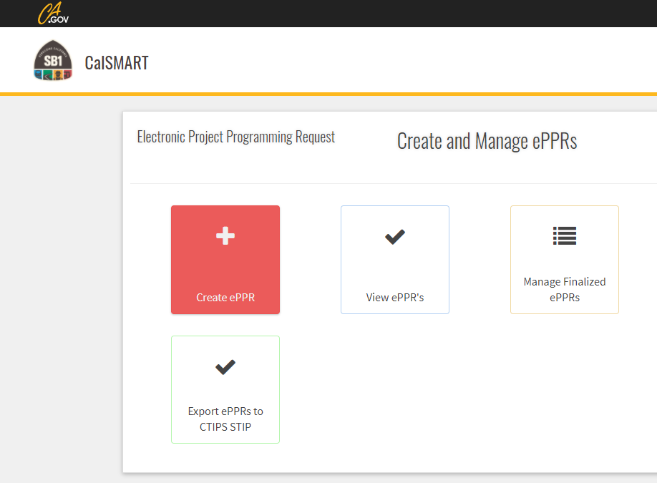
- Click on “Create Blank ePPR”.
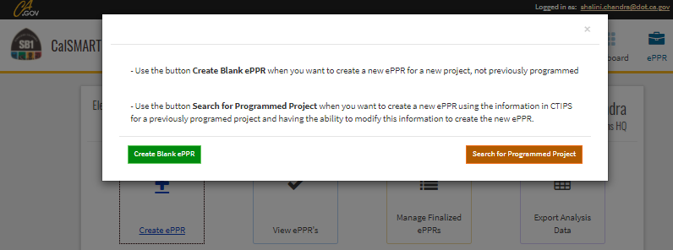

- General Info: Please provide the required information (required fields are marked with an asterisk).
- Select ‘OTHER’ from the Program dropdown
- Fill out all other required* fields and click ‘Save Draft’ in the Sections panel on the right to save draft. This step is required to save initial draft that can be edited at a later time.
- The implementing agencies selected on this page would appear as the only options on the implementing agency tab, so make sure all required agencies are listed here.
- If you’d like to share this ePPR for review while you are working on it, please add the regional agency in the co-nominating agency so they would be able to view it.
- Click ‘Save Draft’ at the bottom right on the Sections panel. At this point the draft ePPR can be printed as pdf for sending for reviews and comments.
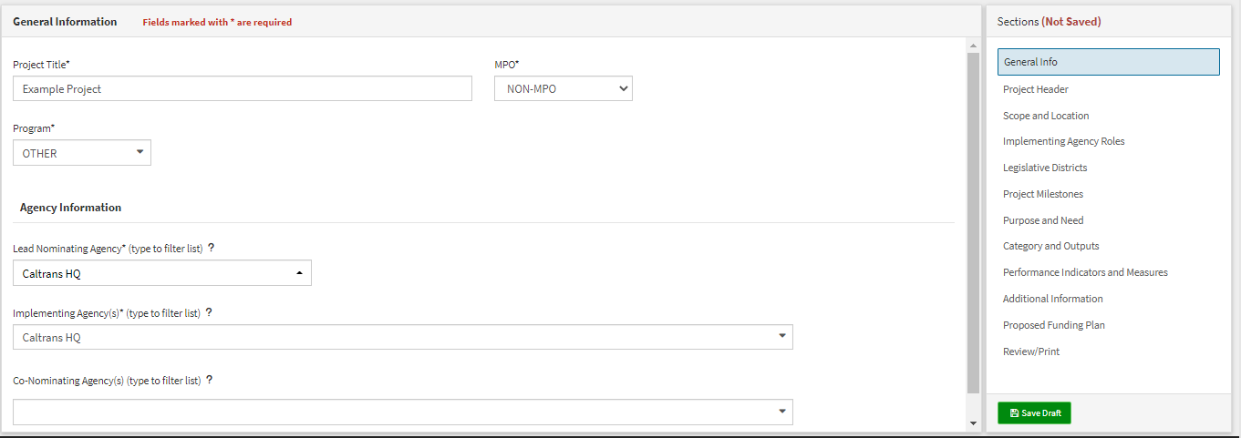
- After saving, the screen will reload with additional fields. Under “Cycle”, you should see “Other 21/24”.
NOTE: Project Title should match CTC Project Listing
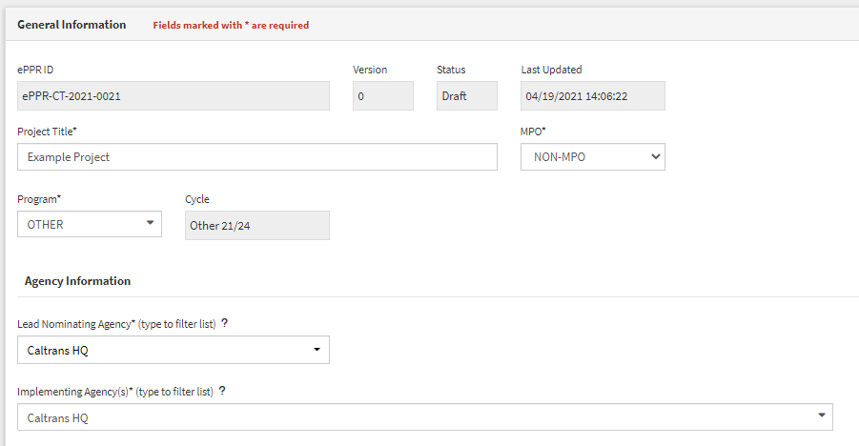
- Go through all the Tabs, listed in the sections area on right and fill out all required* fields and click ‘Save Draft’ on each tab to save and verify the information on that tab is accurate. For additional information about data fields on each tab besides the ones listed below, please refer to the ePPR Users Guide.
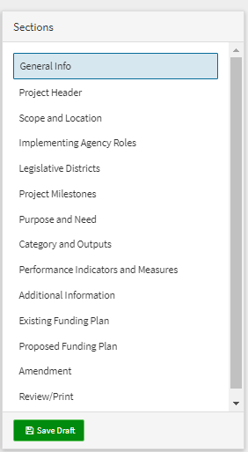
- Project Header: Please provide all required information.
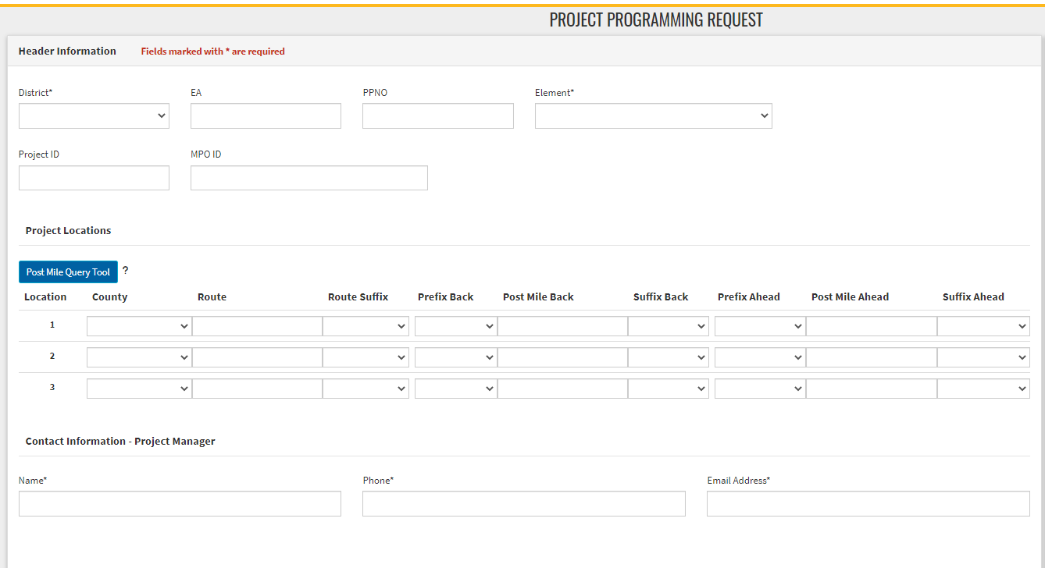
If the Project is located in one, two, or three counties: Select each county from the drop-down menu and type in the route and post mile information associated with each county.
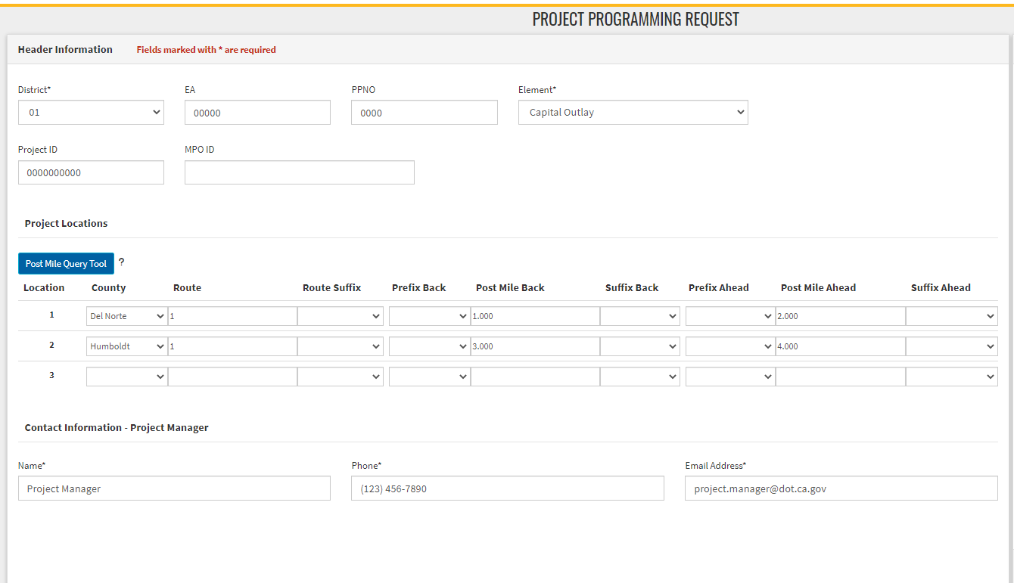
If the Project is located in more than three counties: Select “Various” from the drop-down menu and type in the route.
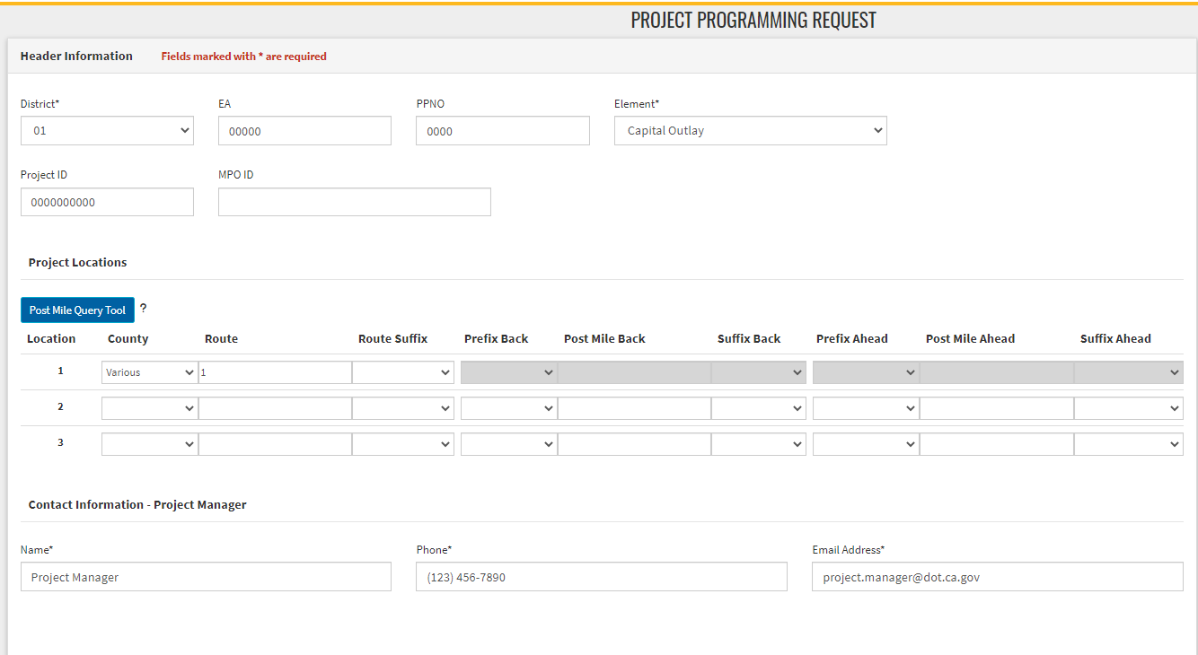
Click “Save Draft” in the bottom right corner of the screen.
- Scope and Location: Please provide a brief description of the project location. See the “Guidelines” section listed below the text box. The “Location (Project Limits)” is a brief description of the project location. The “Description (Scope of Work)” is a brief description of the elements of work. (Note: A more detailed scope and benefits of the project will need to be included in the ‘Purpose and Need’ section.) If additional space is needed use the Additional Information section. Click “Save Draft” in the bottom right corner of the screen.
Eligible Project Types Include:
- Projects that are eligible under the Surface Transportation Block Grant Program (new and existing)
- Routine maintenance/rehabilitation projects (new and existing)
- Projects funding operations
  - Example Description: The project will help augment operational costs for the local ___________________________. (Options include: local government labor costs, administrative costs, costs of utilities, and rent, for the highway surface transportation operations of local governments. May also fund bus and transit operations.)
- Projects funding personnel - including salaries of employees or contractors
  - Example Description: The project will augment current personnel resources to enable the City to resume pre-COVID workload, primarily with project delivery.
- Debt service payments; availability payments and coverage for other revenue losses
  - Example Description: Debt Service payment for local bond measure ABC. Bond issued in 2019 for infrastructure improvements in the City of __________. Projects include Ocean Front - Complete Streets, Various Intersection Improvements, and local street rehabilitation.
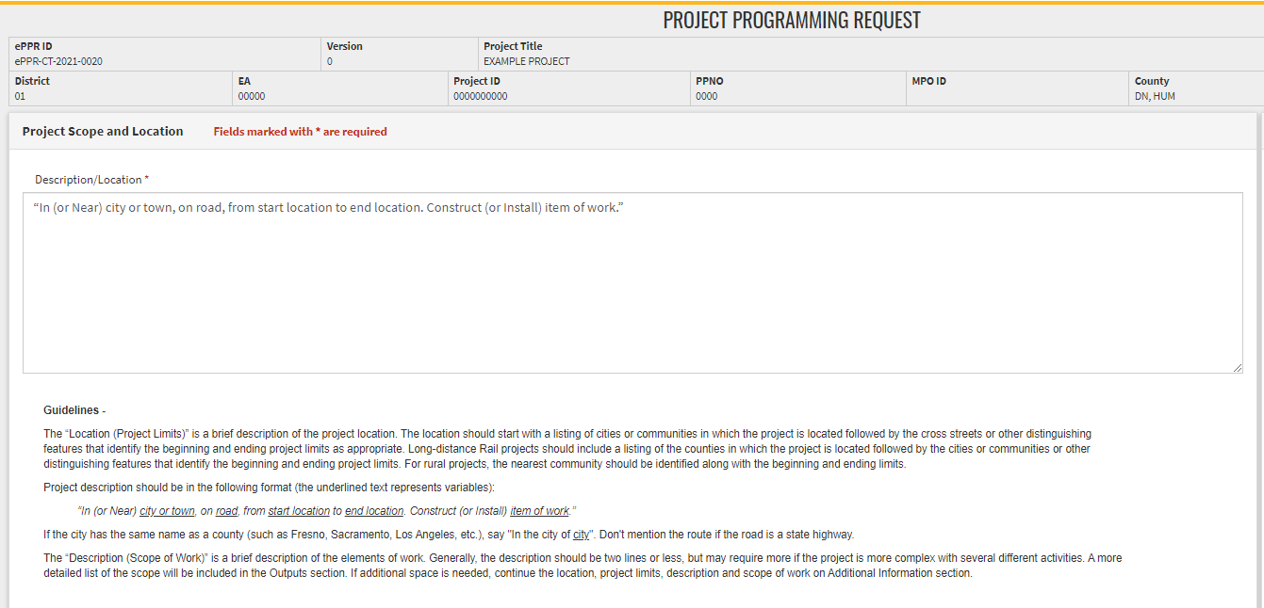
- Implementing Agency Roles: Identify the Implementing Agency for each phase of the project. Click “Save Draft” in the bottom right corner of the screen. As mentioned before, the options for implementing agencies are limited to the one selected on the General info tab. All implementing agencies selected on general information tab must be listed on this page. 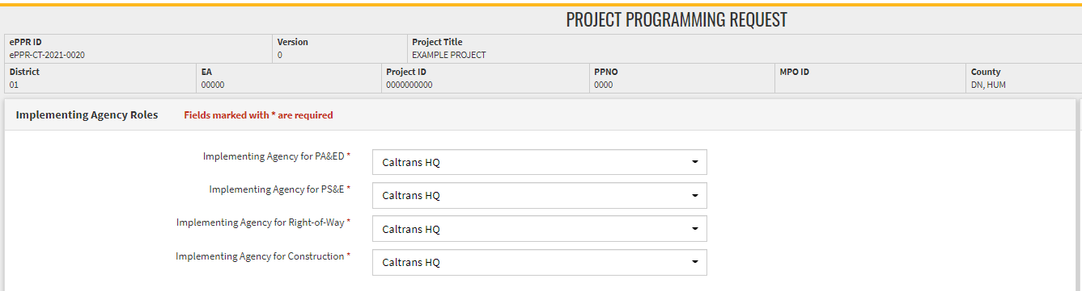
- Legislative Districts: Select the Legislative Districts (Senate, Assembly, and Congressional) associated with the project location. Click “Save Draft” in the bottom right corner of the screen.
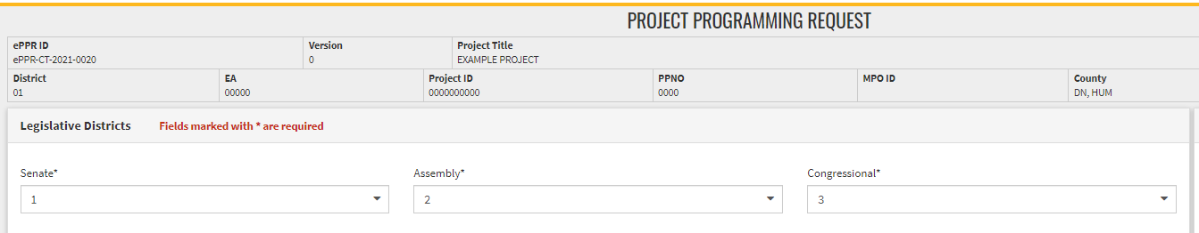

- Project Milestones: Enter the proposed schedule (or actual completion) of various project milestones. For “Document Type”, select the environmental document being used for the project from the dropdown menu. There may be projects that don’t have all the project delivery phases but it is a limitation of the system that requires all dates to be filled in chronological order. Click “Save Draft” in the bottom right corner of the screen.

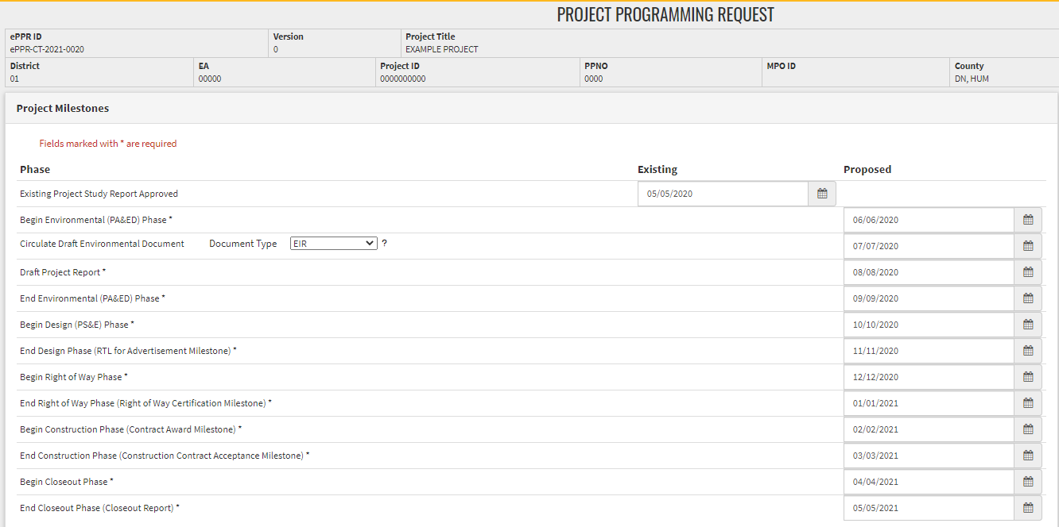

- Purpose and Need: Provide a brief purpose and explanation of the need for the project. If additional space is needed, continue the Purpose and Need in the Additional Information.
Please select items from the dropdown menus (all fields are required). Click “Save Draft” in the bottom right corner of the screen.
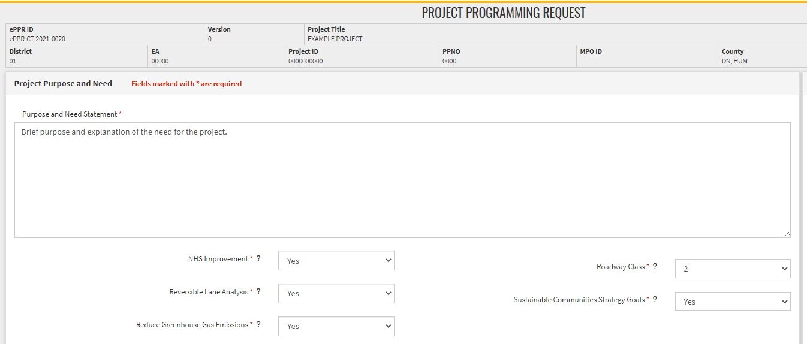

*Purpose and Need:
- Projects that are eligible under the Surface Transportation Block Grant Program (new and existing)
- Routine maintenance/rehabilitation projects (new and existing)
- Projects funding operations
  - Example: The purpose of this project is to help augment operational costs for the local _________________. The local ___________ was severely impacted during the pandemic and low revenues impacted _____________________.
- Projects funding personnel - including salaries of employees or contractors
  - Example: The City was unable to maintain a full complement of staff due to the prolonged impacts brought about by COVID. The purpose of this project is to allow the City to resume standard workload levels that closer resemble pre-COVID levels.
- Debt service payments; availability payments and coverage for other revenue losses
  - Example: The purpose of this project is to facilitate payments to the Local Bond ABC in the City of __________. The City entered into the Bond in 2019. The Bond funds were utilized for various City transportation infrastructure projects including Ocean Front - Complete Streets, Various Intersection Improvements, and local street rehabilitation.

- Category and Outputs: At least one output is required by the system. Use Category and Output related to the infrastructure benefit that is provided by the project and fill in the total field. Then click “Add Output”.
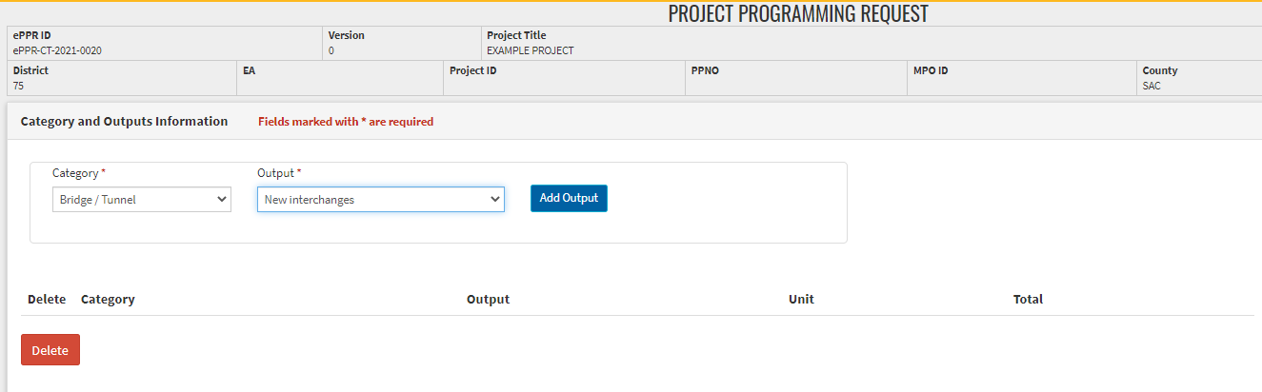
Enter the quantity for each output in the “Total” column. To add another output, repeat the process listed above (select category and output; click “Add Output”; enter “Total”).
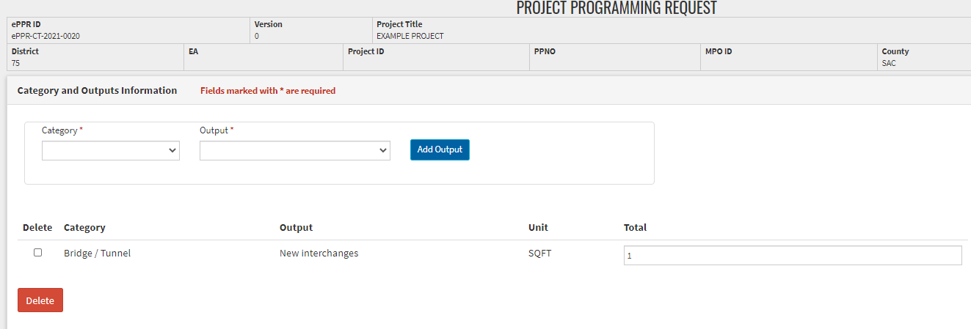
If there is any explanation about assumptions and limitations of the outputs value, please add the relevant information in the Additional Information Tab. Click “Save Draft” in the bottom right corner of the screen. If the project doesn’t provide any infrastructure benefit, please select any one category and output, and click on ‘Add Output’ and add ‘zero’ in the total columns.
Zero = Not Applicable.
- Performance Indicators and Measures: At least one performance measure is required.
To add Benefit, select Measure and relevant indicator from the drop-down menu and click on ‘Add Benefit’.
Providing project level benefit would help measure and document the total benefits at the regional level. If the project doesn’t contribute to any performance and measure, please select any one measure and indicator, and click on ‘Add Benefit’ and add ‘zero’ in the value columns. Zero = Not Applicable.
If there is any explanation about assumptions and limitations of the Performance Indicators value, please add the relevant information in the Additional Information Tab.
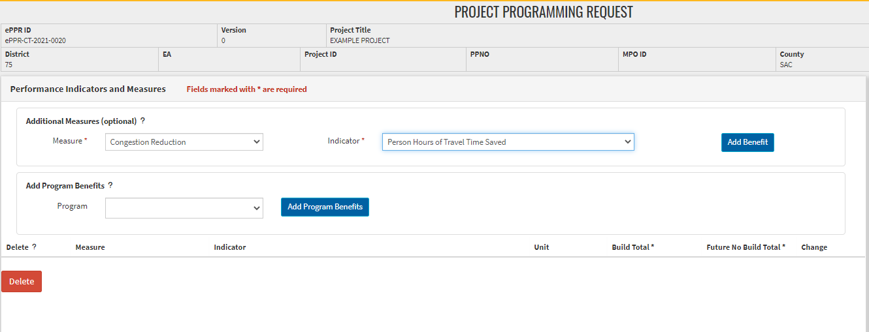
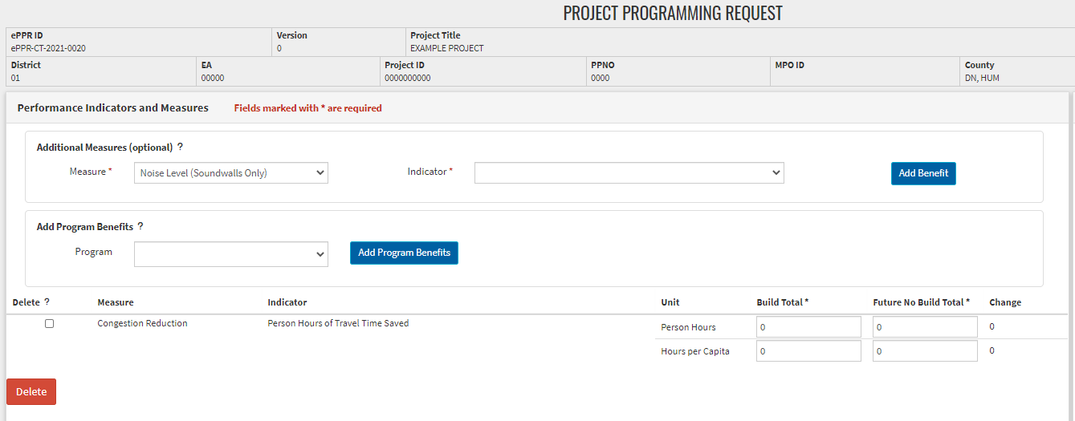

- Additional Information: Use this section for overflow of information from previous tabs and also to communicate any assumptions or restrictions about the project data or the ePPR module validation restriction so we can be aware of it.
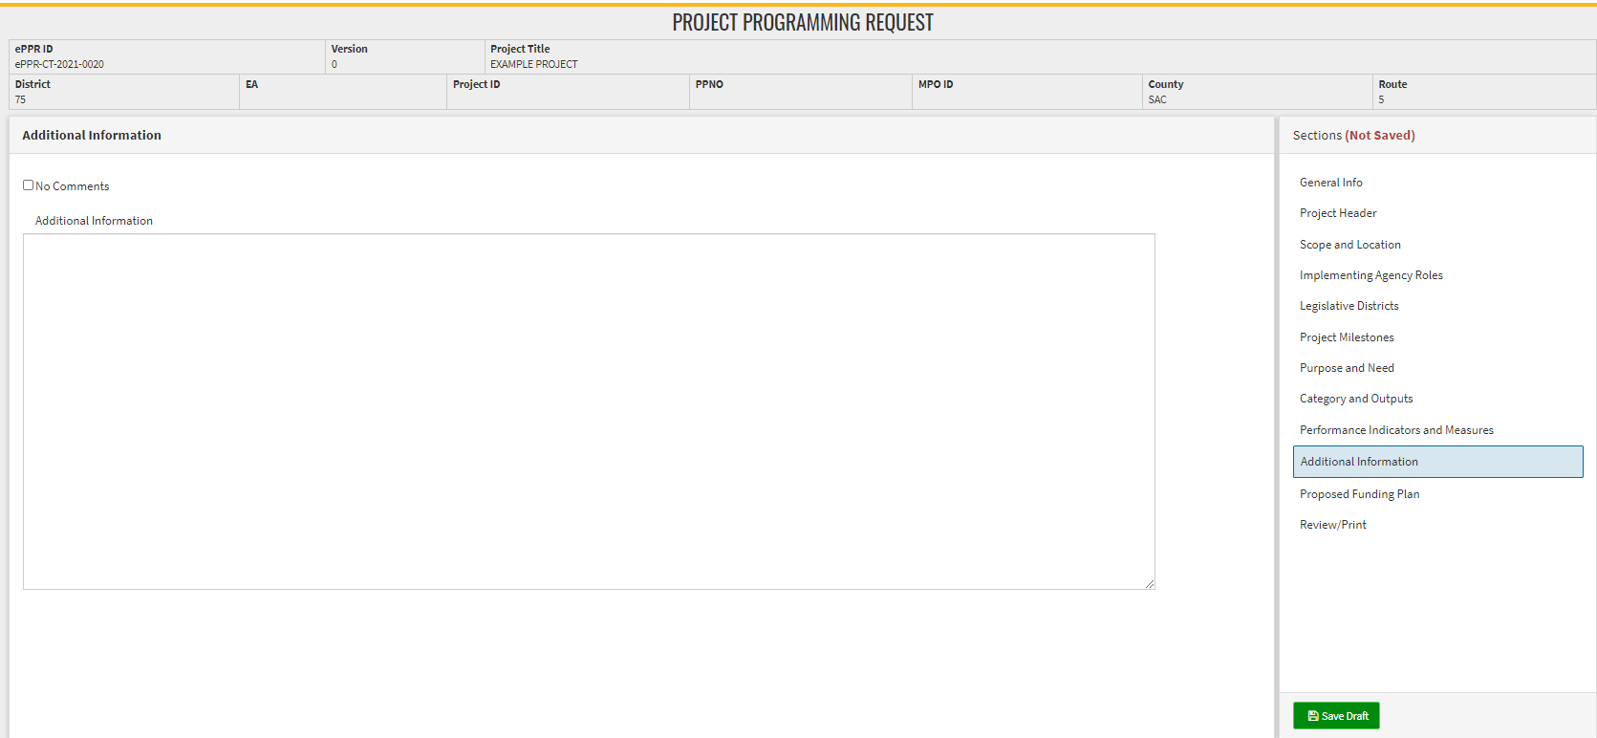
If there is no information to be shared, please check ‘No Comments’.
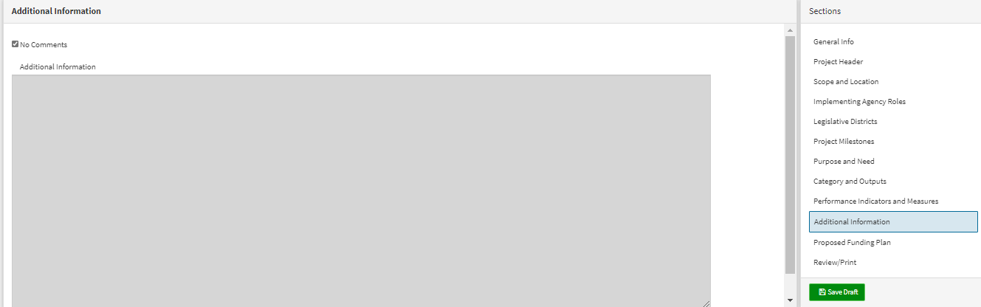
Click “Save Draft” in the bottom right corner of the screen.
- Proposed Funding Plan: The Funding portion of the Project Programming Request provides a detailed view of the proposed project programming. Each funding source is broken down by phase. All programmed component amounts must be escalated to the appropriate fiscal year and rounded to thousands.
Click “Add a Funding Source” – either the blue link or the green button (bottom left corner).
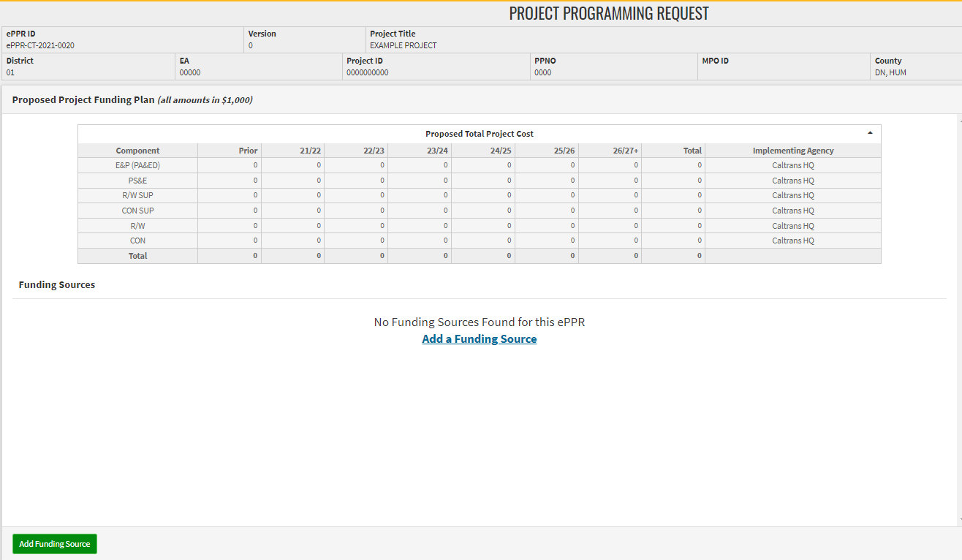
For Other Federal Funds, enter the following information:
Fund Category: Select “Other Fed”
Fund Description: Select “Coronavirus Response and Relief Supplemental Appro”
Committed: Select “No”

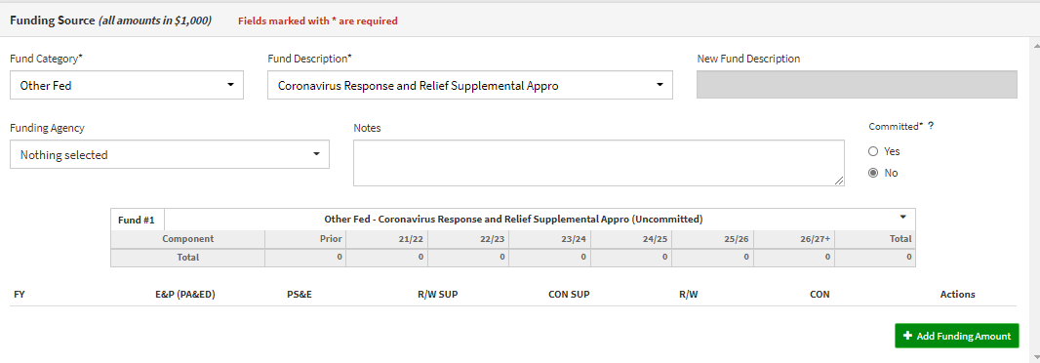
Then Click the “Add Funding Amount”. Enter FY (YY/YY) and funding amounts (per $1000) for the phases associated with COVID Relief Funds.
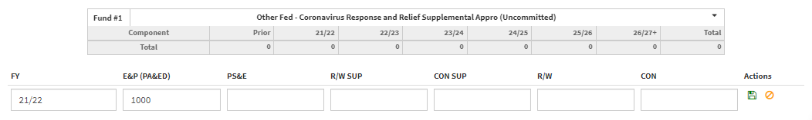
Click the green floppy disk icon (under “Actions”) to save.
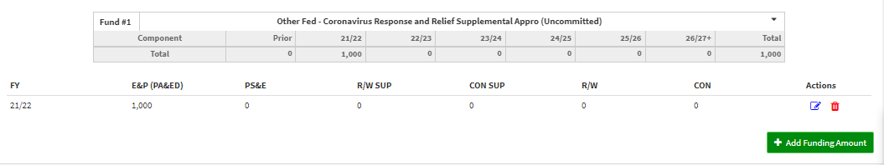
Add additional fund sources and amounts as needed. Click the green “Save” button at the bottom of the Sections pane.
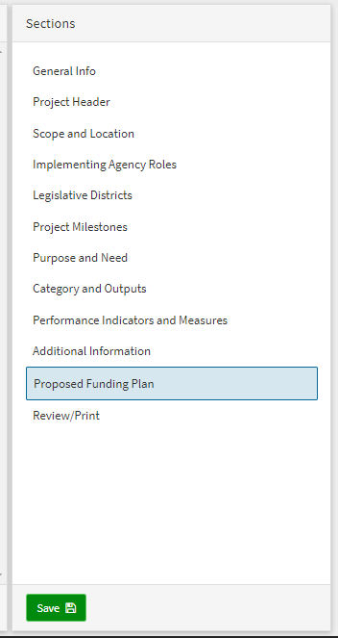 Funding sources should now be listed below the Proposed Funding Plan.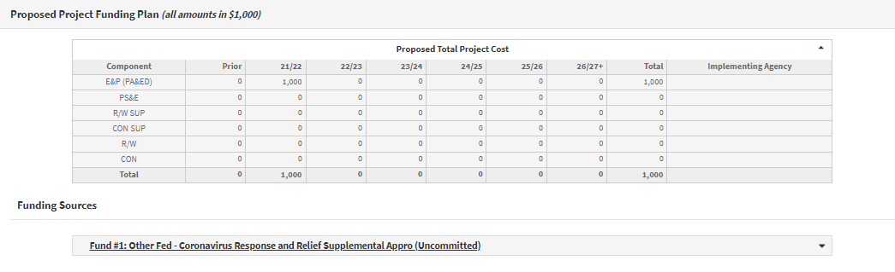

- Review/Print: Ensure that each section is complete, with “NO ERRORS” and a green checkmark (No Error indicator). If there is an error, a black exclamation mark will appear next to the section, along with a red description of the error. Please remedy errors as necessary, until all sections have the green checkmark.
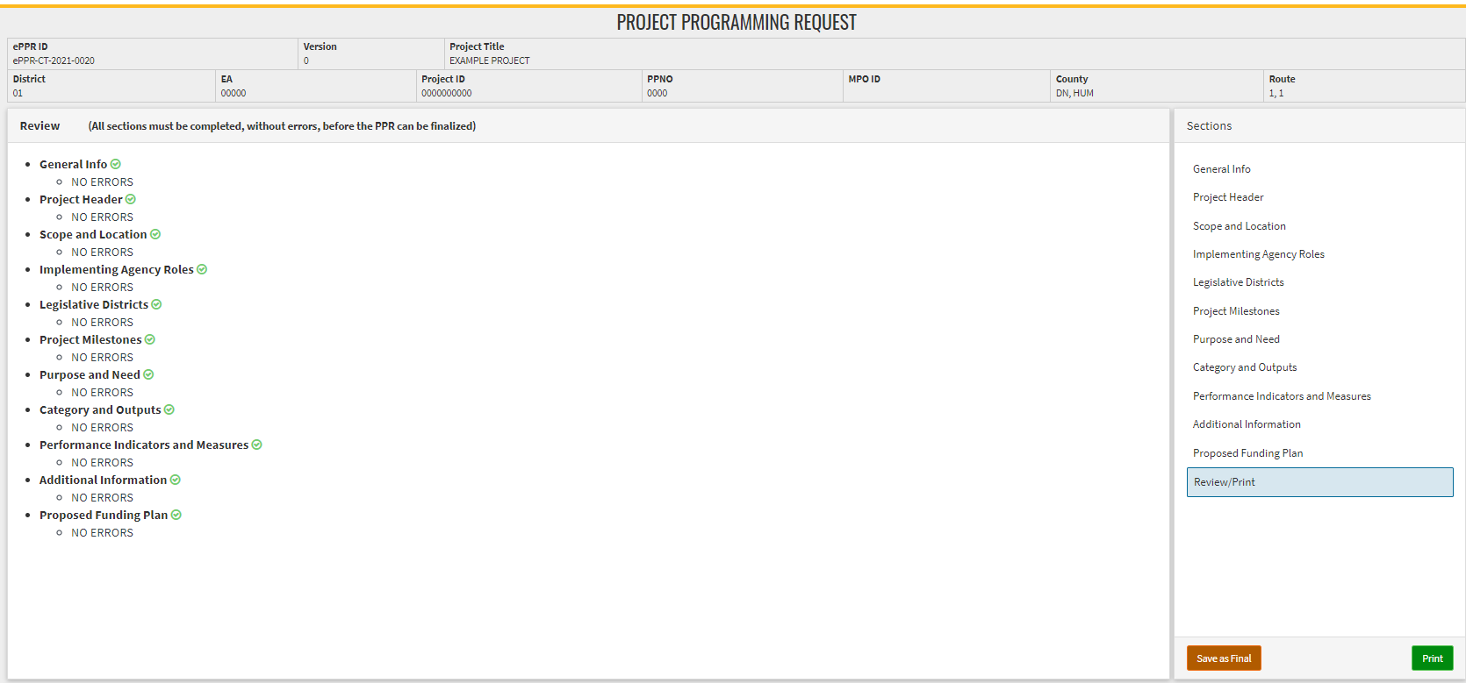
The Button ‘Save as Final’ will appear on the review Tab when there is a green check (No Error) indicator next to all tabs.
DO NOT SAVE AS FINAL if you want to review and make any changes to the ePPR.
You may print the ePPR at any point to generate a pdf (with draft watermark) that can be shared for review and comments.
To Finalize the ePPR, click “Save as Final” and generate a Print pdf without “draft watermark”. All final ePPR submissions should be finalized to allow for project programming and implementation action.
If edits/updates need to be made to a finalized ePPR before a deadline, click on the “Copy” icon and create a new version, make edits, and save as final. Make sure to submit the most updated/relevant ePPR with the application.

- To edit the Draft ePPR before it is ‘Saved as Final’, click on the ePPR ID in the ‘View ePPR’ list.
Do not click copy/ duplicate the ePPR, in order to edit it.
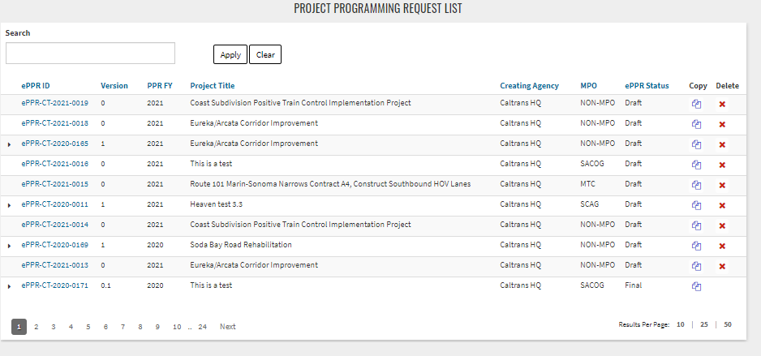

- If edits/ updates must be made to a finalized ePPR before the application deadline, click on the ‘Copy’ icon, and create a new version, make edits, and save as Final. Make sure to submit the most updated / relevant ePPR with the application.
